背景研究

扔粉笔Android

<http://www.wandoujia.com/apps/pusuke.chalksleeper>

日文界面理解不易

背景音乐混乱嘈杂

没有难度设置

疯狂的教室Android

<http://www.wandoujia.com/apps/com.andrphone.crazyclassroom>

同上

给小朋友带来不好的影响：暴力

扔鞋子Windows

<http://apps.microsoft.com/windows/zh-cn/app/cb8dfd05-49db-4042-96f1-67304333a904>

扔鞋子的范围太小，其余部分无用。

没有详细的游戏结果界面，例如游戏时间，命中次数，命中率。

没有设置难易程度。

You Dumb I Dump HD

<http://www.ipadown.com/you-dumb-i-dump-hd-review>

提升：

难度设置

课程选择

Background Research

In the topic of our project, we found there are several chalk-throwing games in different platforms, such as Android, Windows, and iOS. But for iPad, there is none application we have access to in App Store China Region, which strongly drives us to design the interesting game.

Hereunder we did some background research for the similar applications to get a better understanding for the project.

1. Chalk Sleeper for Android

<http://www.wandoujia.com/apps/pusuke.chalksleeper>

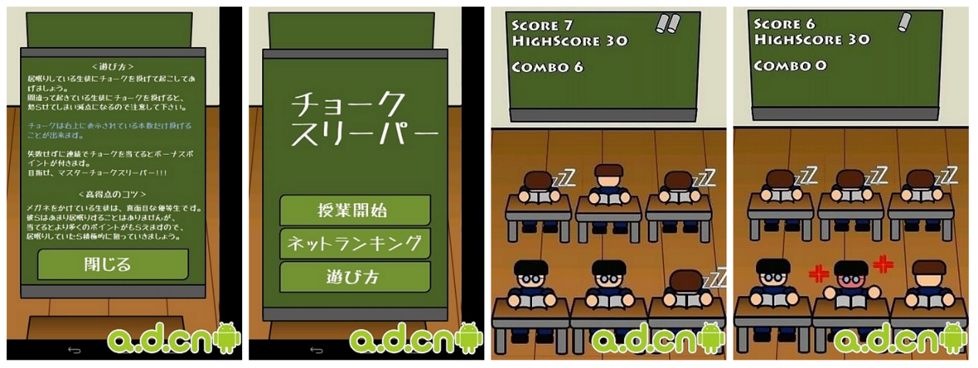

It is a Japanese application for Android, and the game layout is quite simple. Assuming you are a teacher and some of the students are falling asleep during your class, so you can use chalk to wake them up. When you hit the students wrongly (hit the non-sleeping student or not hit any student at all) three times the game will over and the blackboard in the screen will show the records of your game: your score, high score and combo numbers.

The short comes of the application are obvious that,

1. The application is designed in a Japanese version and it is difficult for the player who don’t understand any Japanese.
2. The background music is noisy but no option to turn off except through the volume of smart phone itself.
3. No any other choice for different level, to some players the game is even endless.
4. Crazy Classroom for Android

<http://www.wandoujia.com/apps/com.andrphone.crazyclassroom>

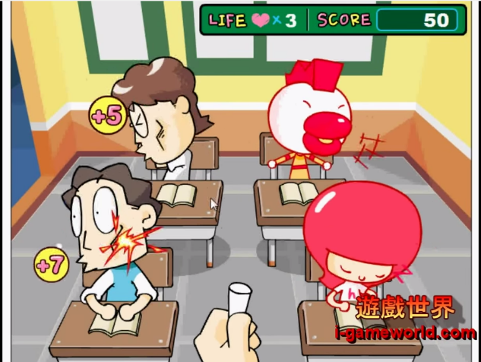

Similar to the first application, it’s a Korean application with four students sitting in the classroom. And for these foreign applications, the biggest problem is the language difficulty for us to understand the functions. Apart from the problems missioned in the first application, this application use some extreme pictures and background music, which may have some violence effects for the teenage players.

1. Throw your shoes for Windows 8

<http://apps.microsoft.com/windows/zh-cn/app/cb8dfd05-49db-4042-96f1-67304333a904>

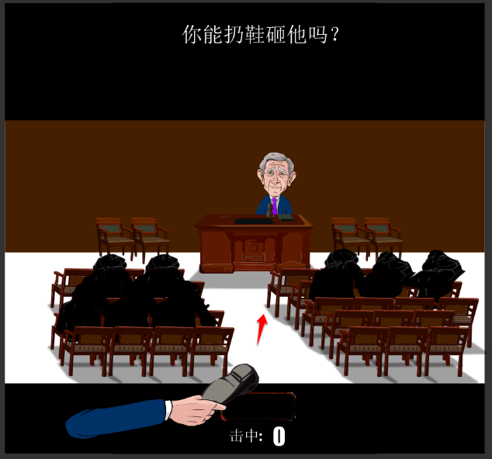

This is a similar application in Windows, with just one objective moving left and right in the counter. There is a swinging red arrow in the bottom of the screen where you can click the “Throw shoes” button, and the second you click the button, the direction of shoes will be determined by the red arrow and then flying to the counter. If you can hit the objective (actually a terrible speaker) in 1 minute, there will be a new page displaying “You can!” to show the result.

The limitations for the application are:

1. The range for the players to throw the shoes is just the counter, and other parts in the screen are useless.
2. There is no clear feedback of the game result, for example the consumed time, the
3. You Dumb I Dump HD

<http://www.ipadown.com/you-dumb-i-dump-hd-review>

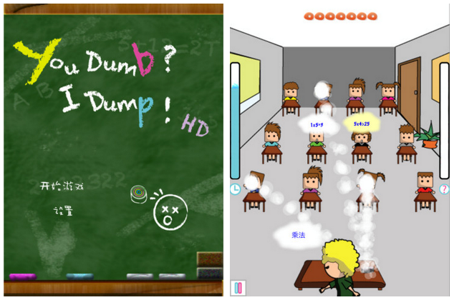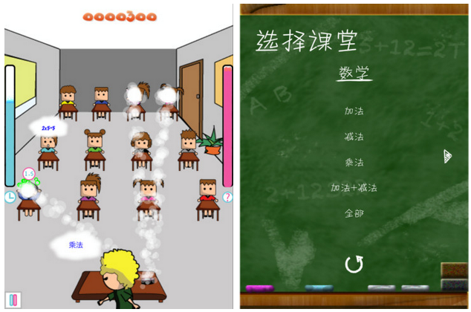

This is a good application which combines the chalk-throwing and question-answering ideas together. When the player starts the game, he can choose the course he wants to take, as well as some subclass to attend. And in a given class, there are some equations and in equations at the top of every students and the teacher can throw chalks to the students with wrong answers. And the whole game is calculated by time with a time chart in the left of the game layout. Since it cannot be downloaded in Apple Store China region, we just go through it by the introduction of the game and get a quite general understanding of the application.

As far as we can see, there still may be some possibility to improve:

1. We can set different levels for the players by changing the numbers of students, it is understandable that the more the students the harder the game will be
2. For the diversity of the game, maybe more courses can be added into the applications not just math and English.